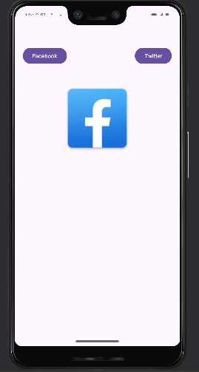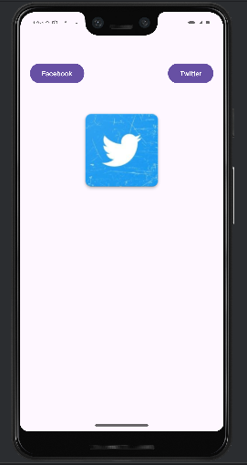

activity_main.xml

<?xml version="1.0" encoding="utf-8"?>  
<LinearLayout xmlns:android="http://schemas.android.com/apk/res/android"  
 xmlns:app="http://schemas.android.com/apk/res-auto"  
 xmlns:tools="http://schemas.android.com/tools"  
 android:id="@+id/main"  
 android:layout_width="match_parent"  
 android:layout_height="match_parent"  
 android:orientation="vertical"  
 android:paddingTop="50dp"  
 android:layout_marginTop="50dp"  
 tools:context=".MainActivity">  
  
 <LinearLayout  
 android:layout_width="match_parent"  
 android:layout_height="wrap_content"  
 android:orientation="horizontal"  
 android:paddingHorizontal="20dp">  
 <Button  
 android:id="@+id/button"  
 android:layout_width="wrap_content"  
 android:layout_height="wrap_content"  
 android:onClick="showFacebook"  
 android:text="Facebook" />  
  
 <Space  
 android:layout_width="wrap_content"  
 android:layout_height="wrap_content"  
 android:layout_weight="1" />  
  
 <Button  
 android:id="@+id/button2"  
 android:layout_width="wrap_content"  
 android:layout_height="wrap_content"  
 android:onClick="showTwitter"  
 android:text="Twitter" />  
  
 </LinearLayout>  
  
 <ImageView  
  
 android:id="@+id/imageView"  
 android:layout_width="185dp"  
 android:layout_height="262dp"  
 android:layout_gravity="center"  
  
 app:srcCompat="@drawable/facebook" />  
  
</LinearLayout>

ActivityMain.java





